BTSHOL07: Integration with Azure Service Bus Queues and Topics
90

This lab will demonstrate how to integrate with Azure Service Bus Queues and Topics
Overview
After completing this lab, you will be able to:
Objectives
- Integrate with Azure Service Bus Queues and Topics.
- Persist messages in a SQL database using WCF-SQL adapter.
- Understand the concept of Azure Logic Apps (the instructor will use a Logic App to send the tweets to you, you will not build one).

Receive tweets from a Topic and store these in a SQL database.
Scenario
The instructor built Logic App will use a Twitter API App to get tweets from Twitter and send them to a Service Bus Topic.

Estimated time to complete this lab: 60 minutes
User Name: Administrator
Password: pass@word1

Exercise 1
Create schemas
This solution is going to require two message types, one for the incoming tweets and one for the SQL database table where the tweets are going to be persisted.

Tasks | Detailed steps
- Open Visual Studio solution | - From C:\Labs\Lab 7b\Start\ directory, open Lab7b.sln.
- Create inbound Tweet schema. This schema is the definition of the message received from the Logic App. | - In Solution Explorer, right-click the Lab7b project and select Add->New Item. Select Schema, and set the name to “Tweet”.  - Rename the root node to “Tweet” and add two child elements called “name” and “tweet” (both lower case).  - Select the top schema node (<Schema>) and set the target namespace to “http://A372.Tweet”.  - Save and close the schema designer  When you’re done your schema should look like this:  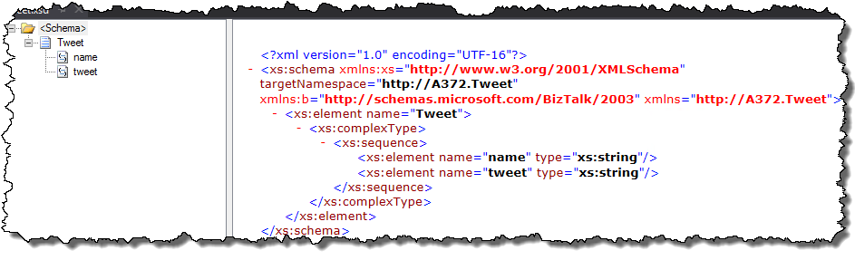
- Create SQL schema. This message type is going to be used to insert each tweet into the SQL database. | - In Solution Explorer, right-click the Lab7b project and select Add->Add Generated Items…  - Select Consume Adapter Service from the left pane, and click Add to open the Consume Adapter Service dialog.  - In the Select a binding field, select sqlBinding.  - Click the Configure button.  - In the Security tab set the Client security type to Windows.  - In the URI properties tab, set Initial catalog to “DemoDB” and Server to “.”.  - Click Ok to close the Configure Adapter dialog and Connect to display all DemoDB database objects in the category pane on the left.  - In the category pane on the left, expand Tables and select the dbo.Tweets table. In the operations list on the right. Select Insert and click Add. Close the Consume Adapter Service by clicking Ok.  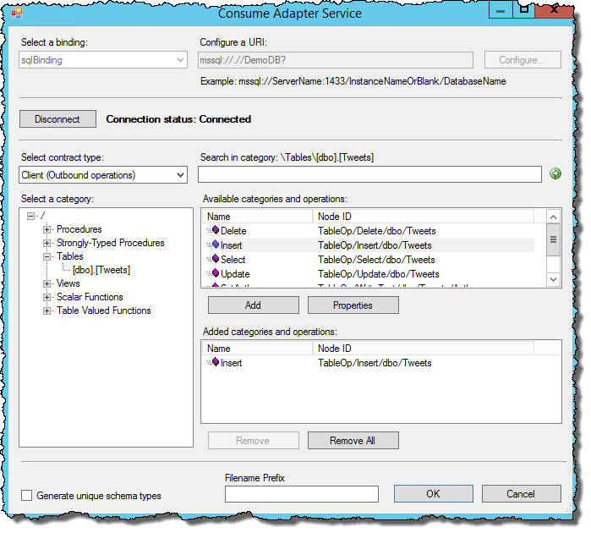  - After closing the dialog, you should see four new files in the project. Examine the files. The file named WcfSendPort_SqlAdapterBinding_Custom.bindinginfo.xml will later be used to create the Send port.

Create orchestration
This solution is going to have one orchestration that will receive a tweet, convert the incoming tweet format to the SQL Insert schema and send it to the SQL database to be saved.

Tasks | Detailed steps
- Create an Orchestration. | - Add an orchestration to the Lab7b project. Name it “TweetProcess”.
- Add Messages. Messages are instances of a schema type, much like variables in C#. | - In the Orchestration View panel, add a message by right-click the Messages node and select New Message. Name the message “msgTweet” and set the Message Type property to Lab7b.Tweet.  Make sure not to set it to Lab7b.Table_dbo.Tweets as that is outbound type.  - Repeat step a setting the name to “msgInsert” and the Message Type to Lab7b.TableOperation_dbo_Tweets.Insert.  - Repeat step a one more time, setting the name to “msgInsertResponse” and the Message Type to Lab7b.TableOperation_dbo_Tweets.Insertresponse.  You should now have three messages.
- Add Shapes | - From the Toolbox drag a Receive shape to the Orchestration designer.  - Set the following properties on the new Receive shape:  - Activate: true  - Message: msgTweet  - Name: “Receive Tweet”  - From the Toolbox drag a Transform shape just below the Receive shape.  - Select the Construct shape and set the Message Constructed to msgInsert.  - Double-click the Transform shape, and set the Fully Qualified Map Name to “Lab7b.Tweet_to_Insert”.  - Set the Source property to msgTweet and the Destination property to msgInsert. Clich Ok to open the BizTalk Mapper.  - Drag the source name field to the destination Author field and the source tweet to the destination Tweet field.  - Save and close the BizTalk Mapper.  - Feel free to change the name of the ConstructMessage_1 and Transform_1 shape to something more appropriate.  - Back at the orchestration designer, drag a Send shape from the toolbox and place it under the Construct Message shape.  - Set the Name of the shape to something meaningful and set the Message property to msgInsert.  - Add a last Receive shape under the Send shape. Set the MessageType property to “msgInsertResponse”
- Add Ports | - Right-click the left Port Surface in the orchestration designer. Select New Configured Port.  - Click Next and set the Name to “RcvTweet”. Click Next.  - Set the Port Type Name to “RcvTweetType”, and Click Next, Next and Finish to close the Port Configuration Wizard.  - Drag the Operation_1 Request to the first Receive shape.  - Right-click the right Port Surface in the orchestration designer. Select New Configured Port.  - Click Next and set the name to “SndDemoDB”. Click Next.  - Set the Port Type Name to “SndDemoDBType” and set the Communication Pattern to Request-Respose.  Database operations generally returns a message indicating the success and status of the operation. For this lab we are going to ignore the response message, but we still have to handle it.  - Change the name of the operation to “Insert”  - Drag the arrow handle from the Send shape to the SndDemoDB Request.  - Drag the arrow from the last Receive shape to the SndDemoDB Response.  You should now have an orchestration that looks something like this:  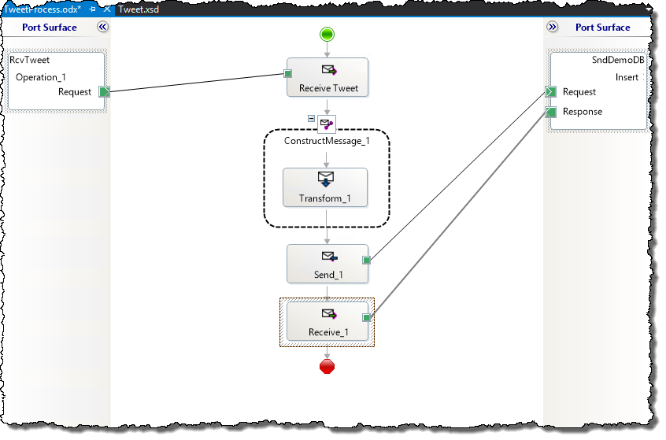

Create pipeline
This solution is going to receive a message from an Azure Topic Subscription which is going to be in a JSON format. Since BizTalk only understands XML, we’ll need to decode the incoming JSON message to XML. This is done using a JSON decoder pipeline component.

Tasks | Detailed steps
- Create Receive Pipeline | - Right-click the Lab7b project and select Add->New Item. Select a Receive Pipeline and name it “ReceiveTweetPipeline”.  - Drag the JSON decoder component from the toolbox to the Decode stage of the pipeline.  - In the Properties box, set the Root Node to “Tweet”, and the Root Node Namespace to http://A372.Tweet  This step is necessary to convert the incoming JSON message (which does not have a root node or namespace) to a XML message that matches the Tweet.xsd schema you created in step 1.  - Drag a XML disassembler component from the toolbox the Disassemble stage.  - Save and close the Pipeline designer.

Deploy solution

Tasks | Detailed steps
- Configure project. | - In the Solution Explorer right-click the Lab7b project and select Properties.  - Navigate to the Signing tab and add a key  - Navigate to the Deployment tab and set the Application to “Lab7b”.  - Save the project  - Right-click the Lab7b project and select Deploy.

Configure BizTalk Application

Tasks | Detailed steps
- Add Receive and send port. The Receive port is going to receive messages from a Azure Service Bus Topic Subscription while the Send port is transmitting the messages to the DemoDB database. | - Open the BizTalk Administration Console, and navigate to the Lab7b Application.  - Right-click the Receive Ports node, and select New one-way Receive Port…  - Set the name of the port to “ReceiveTweets”  - Click Receive Locations in the left pane and click New.  - Set the name to “ReceiveTweets_SB” (as in Service Bus).  - Set the Type to SB-Messaging and click Configure.  - In the SB-Messaging transport properties dialog, update the URL of the Queue or Subscription URL to the one provided by your trainer.  - Navigate to the Authentication tab and update the <Namespace> part of the Access Control Service STS URL to the namespace provided by your trainer.  - Set the Issuer Name and Key to the values provided by your trainer.  - Click Ok to close the SB.Messaging Transport Properties dialog,  - Set the Receive Pipeline to ReceiveTweetPipeline.  - Click Ok to close the Receive Location dialog and Ok to finally close the Receive Port dialog.  - Right-click the Lab7b Application and select Import -> Bindings.  - In the Import Bindings… dialog, browse to the bindings file generated when you created the SQL schema. Should be C:\Labs\Lab 7b\Complete\Lab7b\Lab7b\WcfSendPort_SqlAdapterBinding_Custom.bindinginfo.xml  - Leave all options and click Ok to create the Send Port.  - Navigate to Send Ports to see the port that was imported.  - Double-click on the Send Port, and then click Configure.  - Look at the SOAP Header Action header field, and pay attention where it says:  <Operation Name="Insert" Action="TableOp/Insert/dbo/Tweets" />  The Name of the operation must correlate to the name of the operation name you set in the orchestration port, or the WCF-SQL adapter will not execute the correct action.  - Close all dialogs to get back to the BizTalk Administration Console
- Bind the orchestration | - Navigate to the Orchestrations node and double-click the Lab7b.TweetProcess orchestration.  - Click the Bindings option in the left pane and set the Host to BizTalkServerApplication.  - Bind the logical receive port named RcvTweet to the ReceiveTweet port  - Bind the SndDemoDB logical port to the WCF port you’ve generated through importing the bindings.  - Click Ok to close the Window.  - Right-click the Lab7b Application and select Start.
Test the solution
If all goes well you should have a number of Tweets stored in the DemoDB database. To verify that it has worked, open up Microsoft SQL Management Studio. Navigate to the DemoDB database and query the Tweets table.

Troubleshoot the solution
If there are no tweets in the database, any number of things could have gone wrong. To become an experienced BizTalk developer, you should learn how to troubleshoot. A good starting point would be the Group Hub in the BizTalk Administration Console. Follow the actions depending on what you find in the Group hub.
“There are no suspended or retrying messages”
If you don’t see any suspended or retrying messages in the Group Hub, that means the messages has not reached BizTalk. This is likely due to a miss-configured Receive Location Transport. Open the SB-Messaging configuration and make sure you’ve set them correctly.
“I have messages are in Retrying and idle ports”
If you have messages is Retrying and idle ports, this is likely related to the Send Port. The problem is that the default setting on a Send Port is a retry count set to 3. This means BizTalk will try three times before suspending the message. An easy way to fix this is to go back to the Send Port, click the Transport Advanced Option in the left pane, and set the Retry count to 0. This will force the message to become suspended at once, and you can then easily examine the problem.
Disable the Receive Location and terminate all Running service instances. Enable the Receive Location again, and you should now have messages in the Grouped by Application section of the Group Hub. Proceed to the “I have suspended messages” section below.
“I have suspended messages”
If you have suspended messages, click on the Group by Application link to see a list of all issues. Take the following actions depending on the Service Name:
“ReceiveTweets” (Receive port problem)
If the Service Name says ReceiveTweets it’s likely due to some formatting issues. Open one instance by double-clicking on one of the instances. Click on the Error Information tab and examine the error message.
If the Error message says something like “Reason: After parsing a value an unexpected character was encountered…” (at the end), this likely because the incoming tweets used characters that are reserved by XML such as quotes or “< >” characters. Ignore this issue for now and move on to the next.
If the Error message says something like “Reason: Finding the document specification by message type”, the problem is that the parsed message (after the JSON decoder component) does not match the Tweet schema you created in step 1. Make sure the root node and target namespace of the schema matches the settings of the JSON pipeline component. This is easily fixed by opening the Receive Location and open the settings for the Receive Pipeline. The RootNode should be “Tweet” and the RootNodeNamespace should be “http://A372.Tweet”. If these are your settings, go back to the Tweet.xsd schema and make sure they are identical.
“WcfSendPort_SqlAdapterBinding_...” (Send port problem)
Open the suspended instance by double-clicking it. Examine the Error Information.
If the error message says something like:
Microsoft.ServiceModel.Channels.Common.UnsupportedOperationException: The action "<BtsActionMapping xmlns:xsi="http://www.w3.org/2001/XMLSchema-instance" xmlns:xsd="http://www.w3.org/2001/XMLSchema">
<Operation Name="WRONGOPERATION" Action="TableOp/Insert/dbo/Tweets" />
</BtsActionMapping>" was not understood.
… then the problem is that you have a mismatch between the operation name in the orchestration and the Send port configuration, These must match.

